Register of Sunbeams

The purpose of keeping this register is to assist the Sunbeam Car Club and its members in maintaining contact with Sunbeam owners that are not members and also keeping track of the cars so that should they come up for sale, that we will be the first to know. It’s all about keeping the cars on the road.

For example you may have noticed on the Summer Event that there was a 1975 Fastback Rapier for sale in New Plymouth on the side of the road. One of our members stopped and spoke to the owner, obtained details and that information has been passed on to the Register.

We have set up a computerised system to collate all the information received from the members of the Sunbeam Car Club and other sources.

It is requested that if any member sees a Sunbeam (of any model) in their travels, that they take note of the registration, where it was seen and if possible contact details of the owner.

(The aspect of all privacy issues will be respected under the programme. We will get the owner of the vehicle to sign off on this. There is no intention to on-sell this information to any other party outside of the club or for pecuniary gain.) The information will be strictly confidential.

The registration form is shown on the back of this page.

Send to:

Mike Dimoline, 17 Phoebe Meikle Place, Torbay Heights, Auckland
Or Email: michaeldimoline@xtra.co.nz

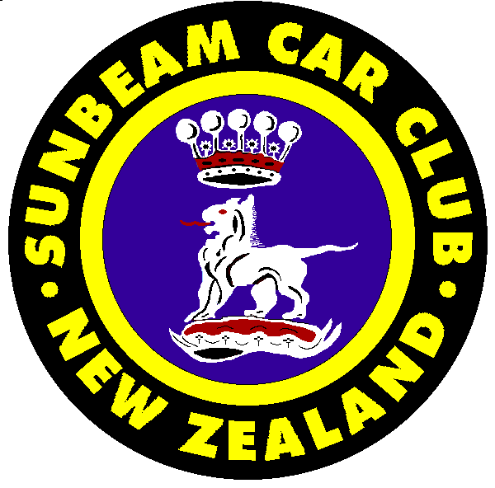  Register Form | (Photo)

Owner/s: Address:

Chassis Number: Model

Engine Number: Year of Manufacture:

Colour: Registration Number:

Body Style: (Convertible, coupe etc)

Extras: (ie Overdrive, Wire Wheels, Hardtop etc)

Modifications: (ie 1725 motor, 5 speed gearbox etc)

History: (restoration work, past sporting success etc)

Previous Owners : (copies of registration papers & photos if possible)

Date: …………………….. Signature: ……………………

The information supplied on this document to the Sunbeam Car Club of NZ will remain strictly confidential and will not be disclosed to any party outside the membership of SCCNZ.
It is therefore agreed that this information will be used solely for keeping a Register of known Marque cars within NZ and will not be used for purposes of solicitation of vehicles.

Please send to: Mike Dimoline, 17 Phoebe Meikle Place, Torbay Heights, Auckland
Or Email: michaeldimoline@xtra.co.nz

